**EV market segmentation project**

By Manjunath Kannavalli

**1. Problem Statement ( EV Market)**

You are a team working under an Electric Vehicle Startup. The Startup is still deciding in which vehicle/customer space it will be develop its EVs.

To analyse the Electric Vehicle market in India using Segmentation analysis and come up with a feasible strategy to enter the market, targeting the segments most likely to use Electric vehicles.

The three most feasible segmentation based on the availability of data are:

1. Geographic segmentation.
2. Vehicle feature segmentation
3. Customer behavioural segmentation

This report and the python code is focused on geographic segmentation only.

Geographic segmentation is an important tool in market research that can help businesses to better understand consumer behaviour and preferences. By dividing a market into different geographic regions and analysing demographic data and economic trends in those regions, businesses can develop targeted marketing strategies that are more likely to be successful in specific areas. This approach can also be used to identify new market opportunities and invest in regions with high potential for growth.

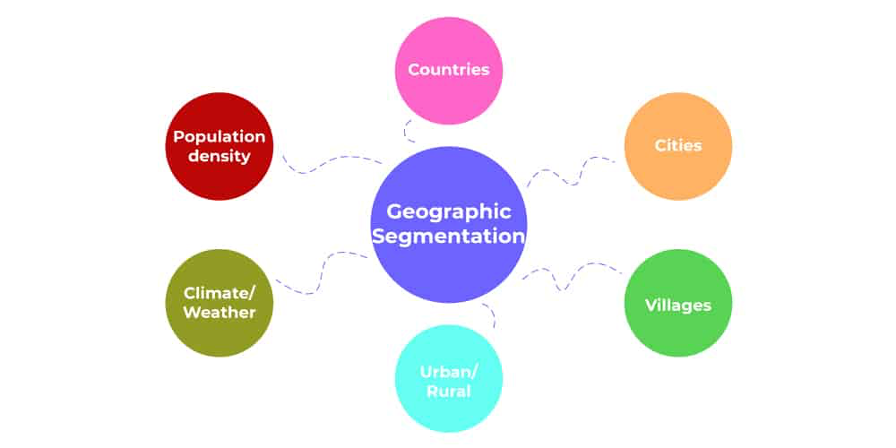

There are several methods that can be used for geographic segmentation in market research, including:

* Regional Segmentation: This involves dividing a market into different regions based on geographical factors such as location, climate, terrain, etc. For example, a sale of EV is influenced by the availability of charging stations at the convenient level. Also, influenced by the government’s initiative towards tax relief, sanctioned EV stations, etc.
* City or Metropolitan Area Segmentation: This involves dividing a market into different cities or metropolitan areas based on population density, socio-economic status, etc. For example, to target consumers in affluent metropolitan areas such as Mumbai, Bengaluru, Chennai, etc.
* Rural-Urban Segmentation: This involves dividing a market into rural and urban areas based on factors such as population density, lifestyle, etc. For example, a company should decide on what type of vehicle is easily penetrable in the market when it comes to Rural areas and Urban areas.

**Data Collection:**

The following sources are used:

* [Government website](https://data.gov.in/) (Number of Charging Stations)
* [Vahan Parivahan](https://vahan.parivahan.gov.in/vahan4dashboard/vahan/view/reportview.xhtml) (Vehicle class wise fuel usage data)
* [Kaggle EV Data](https://www.kaggle.com/datasets?search=+EV+market+data) (Charging Stations on Highways)

**Data Pre-processing:**

Libraries/packages used in python:

* Pandas
* Numpy
* Matplotlib, seaborn
* Geopandas
* Blob
* shapely

Steps involved:

* Data manipulation
* Custom functions for plots
* Drop irrelevant columns
* Reformatting columns to appropriate datatypes
* Merging the data to show insights on India map

Data manipulation (for narrowing down to get relevant fields in the dataset):

This step involves filtering and selecting only the relevant fields or columns from the dataset. This is usually done to reduce the size of the dataset and to focus only on the information that is needed for the analysis. For example, if you are analyzing the EV market in India, you may want to select only the columns that contain data on EV sales, EV models, EV charging infrastructure, etc.

Defining custom function for plots (groupby specific features and get insights):

This step involves creating custom functions to group data by specific features and generate insights. For example, you may want to group data by region or state to compare EV adoption rates or group data by EV model to compare sales figures. Custom functions can help automate these tasks and make the analysis more efficient.

Dropping the features having little or no relevance with E-vehicle:

This step involves removing columns or features from the dataset that have little or no relevance to the analysis. For example, if the dataset includes information on gasoline-powered vehicles, you may want to remove those columns since they are not relevant to the analysis of the EV market.

Cleaning the numerical data and converting it from string to numerical value:

This step involves cleaning the numerical data in the dataset and converting it from a string format to a numerical format, which is easier to work with in data analysis. After analysis, it is found that most of the data were properly formatted.

Merging the relevant dataframes to show EV market insights on India’s Map:

This step involves combining multiple relevant dataframes into a single dataframe to generate insights and visualizations. For example, you may want to combine a dataframe that contains information on EV sales with another dataframe that contains information on EV charging infrastructure. Once these dataframes are combined, you can create visualizations that show the relationship between EV sales and charging infrastructure on a map of India.

**Charging Stations on Indian Highways:**

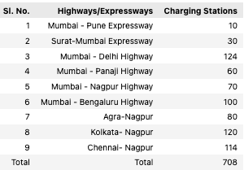

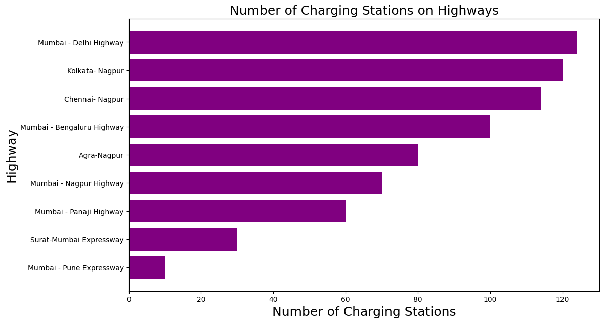

Based on the above plot, the following states could serve as a baseline targets when it comes to geographic segmentation.

* Maharashtra.
* Delhi.
* West Bengal.
* Karnataka.
* Gujarat.

**Sanctioned Charging stations:**

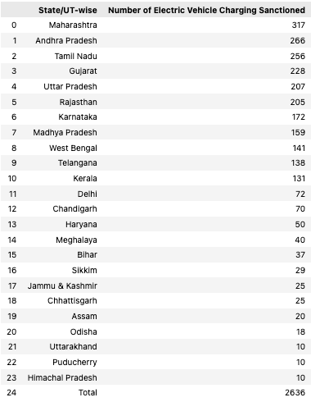

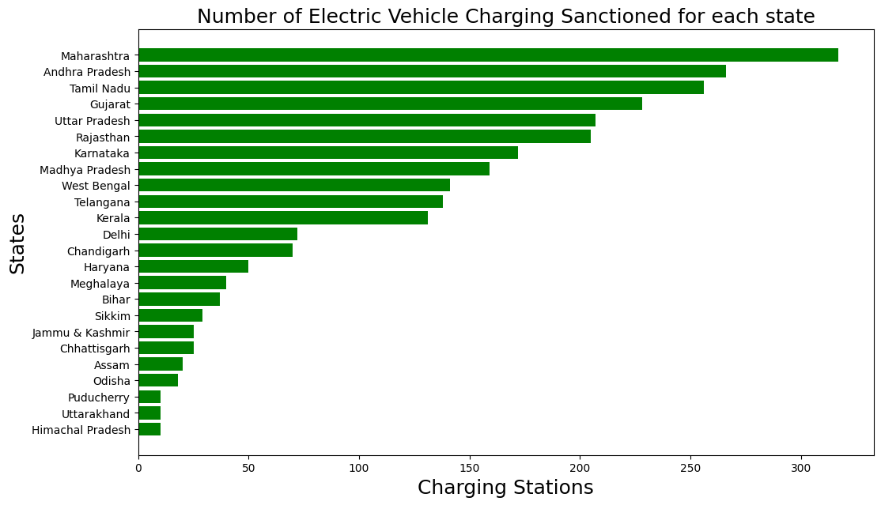

States to target based on charging stations sanctioned:

- Maharashtra

- Andhra Pradesh

- Tamil Nadu

- Gujarat

- Uttar Pradesh

- Rajasthan

- Karnataka

**Vehicle wise fuel data for each state**

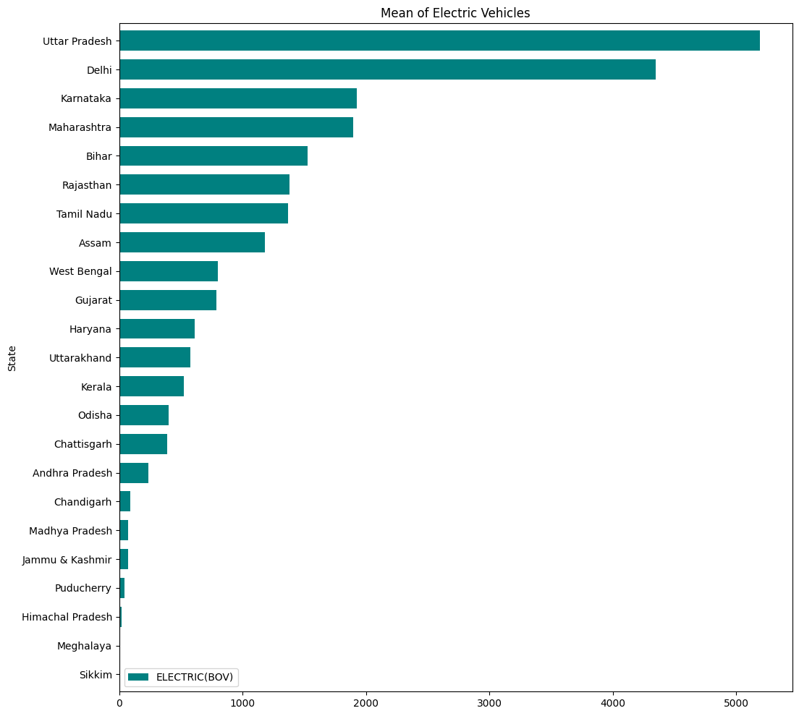

After conducting analysis of the number of charging stations in various states and highways, we have identified the most promising states to enter the EV market. This aligns with our earlier baseline states that we had established. We can now move on to the next phase of geographic segmentation and focus on targeting specific types of vehicles.

To determine the most promising vehicle types, we have analysed the existing number of E-vehicles being used across different states. Based on this analysis, we have identified six states that show the most promise. Our focus will be on targeting these states and capturing a significant share of the EV market.

We are excited to move forward with this strategy and believe that it will position us for long-term success in the EV industry.

The below mentioned states are best to enter our EV vehicle in the market:

- Uttar Pradesh

- Delhi

- Karnataka

- Maharashtra

- Bihar

- Rajasthan

- Tamil Nadu

Vehicle class wise fuel data on one of the above mentioned state:

Uttar Pradesh:

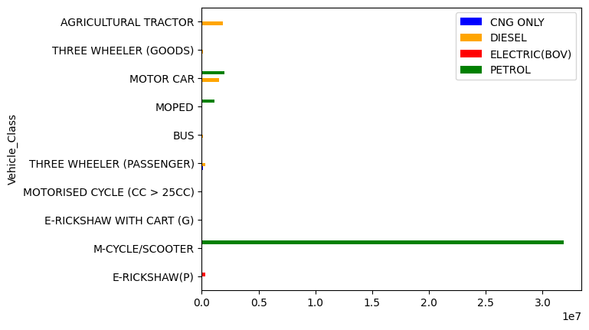

By analyzing the different types of fuels used by vehicles in Uttar Pradesh, we have gained valuable insights into the current state of the market

Furthermore, we have also conducted an analysis of the types of vehicles that currently use electric vehicles (battery-operated vehicles). This analysis has allowed us to narrow our focus and target specific vehicle types that show the most promise for the EV market.

By honing in on these vehicle types, we can develop EV models that are tailored to the needs of consumers in Uttar Pradesh. This will enable us to capture a significant share of the market and position ourselves for long-term success in the EV industry.

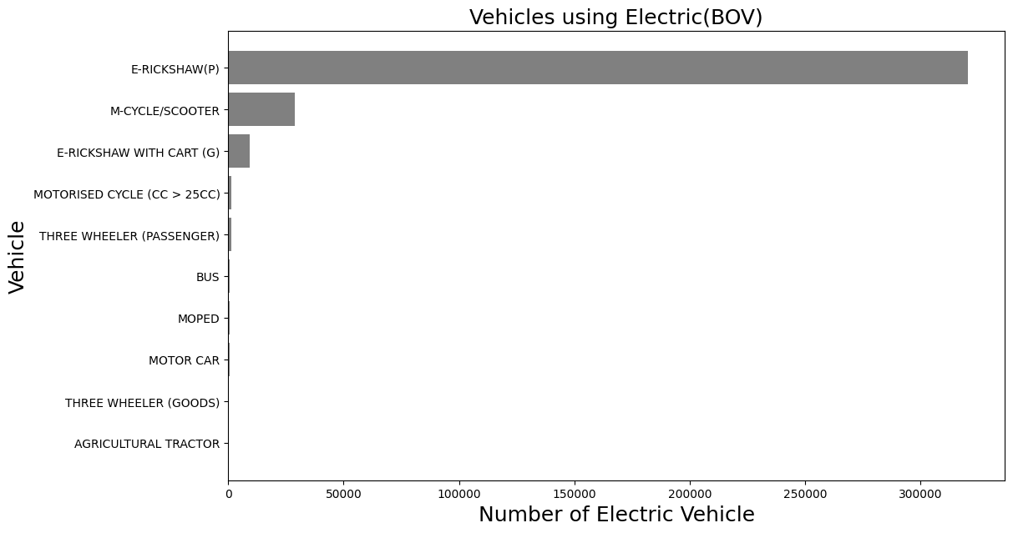

We can see that when it comes to Battery operated vehicles for Uttar Pradesh, E- rickshaw (Passenger), Motor-Cycle / Scotter and 3 Wheeler (Passenger) are the vehicle spaces which should be considered.

**Selection of segments:**

Similar visualisation is carried out based on the states mentioned earlier

The following chart depicts the vehicle type share state-wise so that the company can decide which type of vehicle is feasible in which state to penetrate in the market.

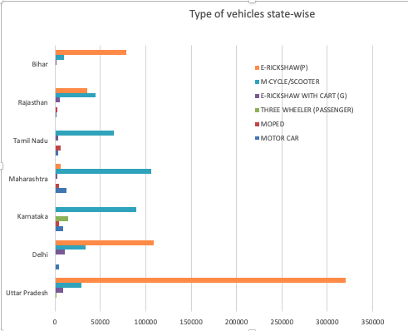

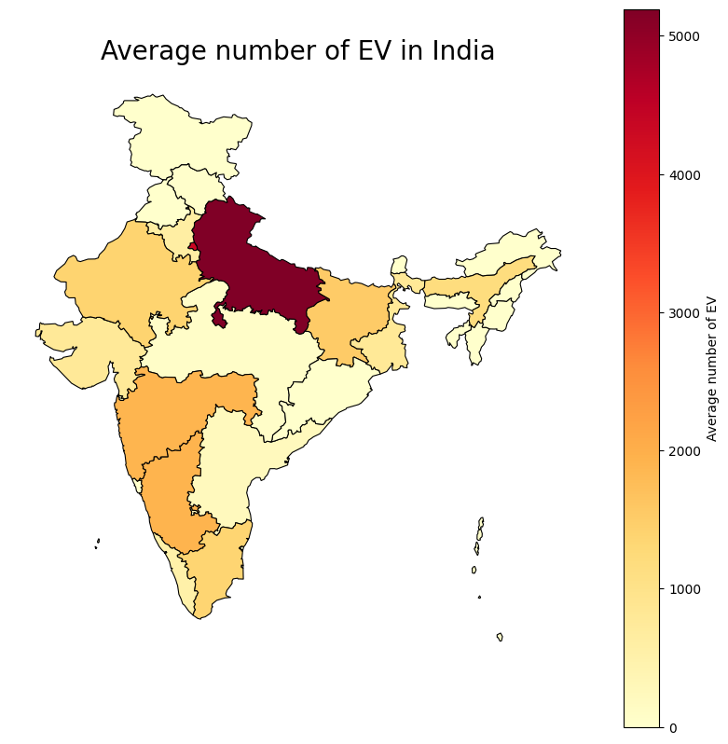 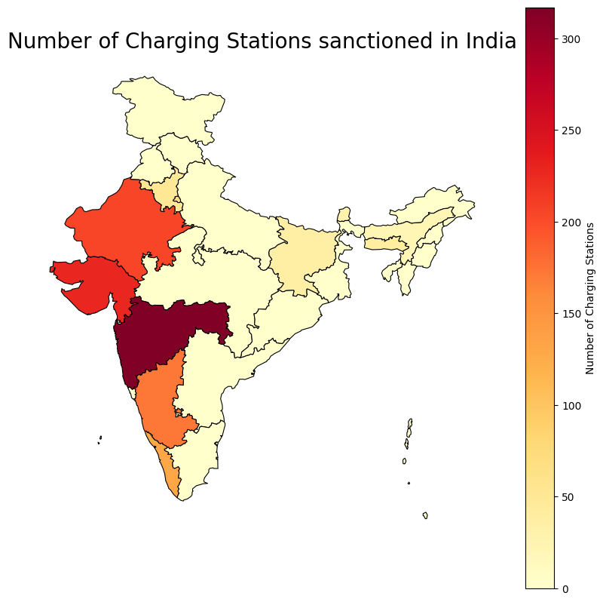

The above maps, constructed with the help of geopandas and shapely provide a final and insightful representation of the Number of Charging Stations and the EV (Battery operated vehicle) used across India.

Conclusion:

* Based on the Number of sanctioned charging stations, people are more likely to opt for EV vehicle due to its convenience. States to focus are:

Maharashtra

Andhra Pradesh

Tamil Nadu

Gujarat

Uttar Pradesh

Rajasthan

Karnataka

* Based on the average number of EV present in India, and charging stations in highways, States to focus are:

Uttar Pradesh

Maharashtra

Karnataka

Gujarat

Tamil Nadu

Bihar

It is evident that, states having lower temperatures are less likely to adopt EVs compared to above mentioned states.

* Based on the type of vehicle predominant in states, Vehicle to focus are:

Motor-Cycle/scooter

Car

Moped

E-Rickshaw

Apart from this, the startup needs to keep informed about

* Government guidelines related to EV rules and regulations state-wise.
* Also, the sentiment of population towards EV vehicles. For instance, the EV vehicle when it comes to personal usage is not bound to social status. But for Rickshaw to be made electric, proper communications need to made to the public as auto drivers aren't economically independent, are reluctant to adopt to new means of transport because of fear of their current vehicle obsoleteness. Some steps include:
* With co-ordination from government and support to those segments can be fruitful in introducing the rickshaw to the market.
* Creating awareness state-wise through celebrities like cricket players, artists to the public about EV vehicle advantages.